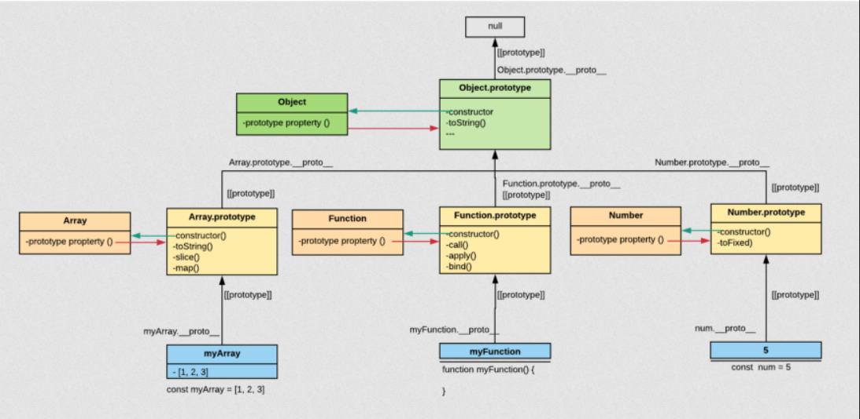

For those coming from languages like c++ or java this type of inheritance may seem very odd.

But it is extremely handy and powerful in it’s own way